**INFO 5100 Project 2 - Final Report**

Team members: Haoyang Li (hl2425) , Yuhao Lu (yl3539) , Yue Wang (yw2359) , Yue Zhao (yz2697)

## **Overview**

|  |  |
| --- | --- |

We present our project 2, *online kitchen*, an interactive visualization that allows users to draft a meal from a set of foods and check whether this meal is healthy or not and find out which states they can get this meal most easily. To the upper left is a selection area where users can drag a food symbol from a list to the plate to constitute a meal. To the upper right is a radar chart displaying the nutrition facts of this meal. To the bottom is a topological map of the United States of America displaying where these ingredients of this meal come from across the country.

The data displayed in these two charts are dynamically filtered according to the foods dragged into the plate. A user first scrolls on the list of food symbols, selects what it wants and drags it to the plate. The overall nutrition facts of these selected foods will be displayed in the radar chart and the state-level production of these foods will be displayed in the bubble map. The user can check whether these foods meet its nutrition needs and find out which state to live in if it wants to get these foods at a cheaper price (i.e. live close to where they are produced).

**Data**

There are two data involved in this project, a dataset of nutrition facts and a dataset of production by state. Both datasets are collected and processed by ourselves. Nutrition facts are scraped from google and production information is acquired from National Agricultural Statistics Service provided by the United States Department of Agriculture.

### **Raw data**

Each entry of nutrition facts dataset takes the following form:

| {  "short_name": "Beef",  "name": "Ground Beef 15% fat, broiled",  "nutrition": {  "Energy": { "quantity": "1,047 kJ (250 kcal)", "dv": null },  "Carbohydrates": { "quantity": "0 g", "dv": null },  "Dietary fiber": { "quantity": "0 g", "dv": null },  "Fat": { "quantity": "15 g", "dv": null },  …..  },  "id": 2  } |
| --- |

There is a “short_name” entry recording the general name for the food, a “name” entry recording the detailed name for the food, an “nutrition” entry containing all the nutrition facts we can gather for this food. Each entry of the “nutrition” dictionary is the quantity and deviation of the corresponding nutrition. There is also an “id” entry to make the processing easier.

Each entry of the production by state dataset consists of an array of production information for each state, each of which takes the following form:

| {  "year": "2020",  "state": "ALABAMA",  "category": "Chicken",  "data_item_unit": "Chicken, BROILERS - PRODUCTION, MEASURED IN LB",  "value": "6,605,000,000"  } |
| --- |

To make it more tractable, we only use the production data from 2020. There is a “year” entry for that. The “state” entry denotes the state name, the “category” entry denotes the category name, i.e. the food name, the “data_item_unit” denotes the unit with which the production is measured and the “value” entry denotes the value of production.

### **Preprocessed Data**

There is no need to visualize all of these nutritions since not all of them are necessary for humans. We filtered out a subset of them and preprocessed each entry of nutrition facts into the following format:

| {  "name": "Chicken",  "id": 0,  "nutritions": {  "Water": 63.9300001,  "Carbohydrates": 1e-7,  "Fat": 12.5600001,  "Protein": 24.6800001,  "Dietary fiber": 0,  "Starch": 0,  "Zinc": 0,  "Calcium": 0,  "Copper": 0,  "Iron": 0.0011601,  "Magnesium": 0,  "Manganese": 0,  "Potassium": 0,  "Selenium": 0,  "Sodium": 0.0670001,  "Phosphorus": 0,  "Choline": 0,  "Histidine": 0.7260000999999999,  "Isoleucine": 1.2330001000000002,  "Leucine": 1.7970001,  "Lysine": 2.0110001,  "Phenylalanine": 0.9590000999999999,  "Threonine": 1.0200001,  "Tryptophan": 0.2760001,  "Valine": 1.1990001000000001,  "Vitamin B6": 0,  "Vitamin E": 0,  "Vitamin K": 0,  "Vitamin C": 0,  "Vitamin A": 0  }  } |
| --- |

For each entry of the production dataset, we calculate the percentage of the productions of each food for each state and an entry of the preprocessed data is shown below:

| {  "state": "ALABAMA",  "latitude": 32.3812,  "longitude": 86.9023,  "Abb": "AL",  "Chicken": 6605000000,  "Chicken_per": 11.885674388306152,  …..  } |
| --- |

## We filtered out oversea states and territories because we intend to plot each state with a scatter plot with horizontal axis and vertical axis as longitude and latitude. These oversea parts will make the plot too sparse.

## **Visual & Interactive Design**

There are two visualization charts and one interaction region. We choose to visualize the nutrition facts of the composed meal using a radar chart and the production map of the composed meal using a scatter chart. The interactive region takes the form of a plate, along with a menu list of food symbols that users can drag food symbols out of the menu list and place them onto the plate.

As long as you put your mouse over one specific food in the food list on the left side of the interactive region, a label beside the food would indicate its exact name. You can definitely drag the food to anywhere you want, and once you place the food on the plate, the radar chart and the production map would be renewed according to all kinds of foods on the plate, indicating the total nutrition per 100-gram food and the production of all kinds of food in different states respectively. But remember, only in the plate area would the food be placed, otherwise, the food you select will go back to its original location in the food list and no visualization would be updated corresponding to the “adding food” event. For simplicity, if you want to delete a food on the plate, simply drag it out of the plate and that would work. In addition, we add a reset button on the left top of the region for convenience, giving users a chance to delete all the food on the plate only through one operation.

|  |  |
| --- | --- |
| Mouse over a specific kind of food | You can only place the food on the plate |

In addition to interacting with the plate, the two visualization charts are also interactive within themselves. The radar chart allows users to mouseover the legend and highlight the corresponding data dots and it also provides tooltips triggered by mouseover for each data dot such that users can check for the specific value.

|  |  |
| --- | --- |
| Mouse over legend ticks for highlights | Mouse over data dots for details |

The radar chart is nothing but a line plot transformed into polar coordinates. Each label denotes a nutrition component and the quantity of that component determines the distance from the data dot to the center of the radar chart. We use a log scale for the quantity because it spans a drastically variant range from 0.000001 g to near 100 g.

The visual channels employed by the radar chart are:

* Length: The variance of data value is encoded by its distance from its center to the center of the radar chart.
* Color Hue: The variance of tick value is encoded by the color hue.

The visual marks employed by the radar chart are:

* Dot: Each data point is marked by a dot.
* Area: The data dots are connected by a filled path, which is marked by a polygon area.
* Color: The ticks are marked using color.

The production scatter plot reflects how the foods on the plate are distributed all over the United States. It is interconnected with the plate interface above. Every time users drag one food onto the plate, it will trigger the update of the map and the map will display the summation of production for each food currently on the plate of each state.

We have some issues here with our dataset of state production. Because the agricultural distribution of the United States shows a kind of fixed pattern, it is possible to lead to the result that for a certain food, one or two states will take the dominant place of the total production, while others only play an inessential role. So the numerical information can be confusing and we decide to use the data alternatively. For each state, we divide them into two classes: “having production” if the production is greater than 0 and “no production” if the production is equal to 0.

The vertical axis here is the latitude of each state and the horizontal axis is the longitude of each state, so the entirety here works equally to the actual map of the US neatly and compactly. Each state is represented by a circle on the plot located according to its longitude and latitude.

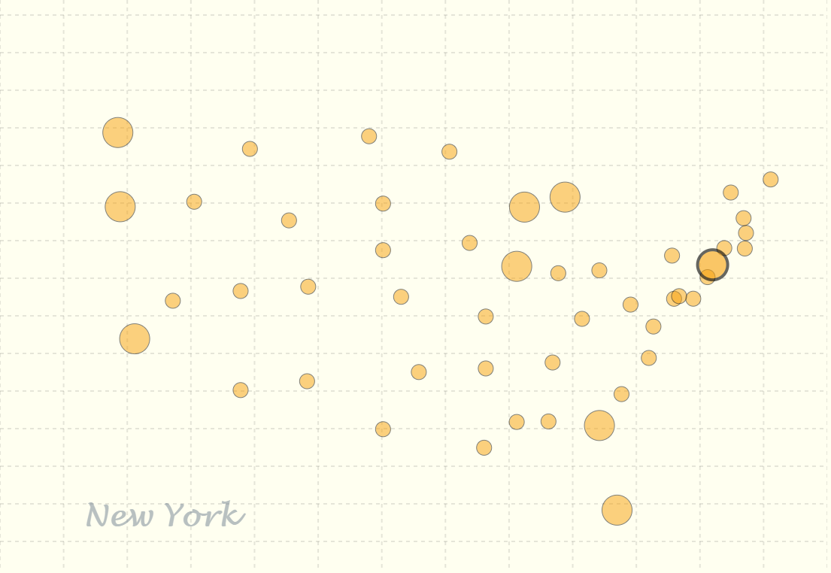

The interaction goes like this. Each circle is in the same size originally and each time users make their choices, the size of circles will change correspondingly. For each state, if it produces this food, the radius of its corresponding circle will grow by a unit (10 pixel). So we can easily tell from the map which state produces the majority of the current foods on the plate.

Besides, for those who may have little acknowledgment of each state’s geographical distribution, we add mouseover attribute for each circle that once users hover the mouse on it, it will display the name of the corresponding state around the bottom left corner so it won’t interfere with other circles.

The visual channels employed by the production map:

* Aligned horizontal position: The variance of the longitude of states is encoded by the aligned horizontal position.
* Aligned vertical position: The variance of the latitude of states is encoded by the aligned horizontal position.
* Size: The variance of the production value of each state is encoded by the size of dots.

The visual marks employed by the production map:

* Dot: The state is marked by a dot.
* Color: The dot is marked with a certain color.

**Here are some justification answers for designing choices:**

Why a plate for an interactive region?

* Cultural Convention: Foods are generally served onto the plate, placing foods onto a plate is quite natural.

Why use dragging to compose a meal (.i.e. filter the selected food list)?

* Cultural Convention: Dragging mimics the daily process we perform to serve a meal, .i.e. it looks like grabbing food and putting it onto your plate.
* Intuition: Dragging is the most intuitive way to compose a food list.

Why exhibit the nutrition facts of food in a unit of 100-gram?

* Convention: In food science, people always determine the amount of nutrition per 100 grams.

Why simply leave the food cupboard blank after dragging out of the specific food instead of allowing users to add the same food multiple times?

* Tradeoff: As mentioned before, by convention in food science, the amount of nutrition in a particular food is measured in a unit of 100-gram. We apply the standard, whereas leading to some obstacles if users would like to customize their food ingredient dedicatedly. Note that users cannot specify the exact amount of food in our design, adding the same food multiple times to the place makes no sense, and thus we abort this feature and leave the food cupboard blank.
* Briefly, we only want users to have a glimpse of the nutrition as well as the production areas of the chosen food, and we just want our visualization to be a reference but not a criterion.

Why a radar chart for nutrition facts?

* Cultural Convention: Nutrition facts are guides for a healthy meal, just like a “radar”, guiding the direction towards health.
* Visual Harmony: The shape of a radar chart aligns well with a plate, promoting visual harmony.

Why use warm colors?

* Cultural Convention: Warm colors are better for appetite.

Why not use a detailed map? Why use the size to encode the production?

* Tradeoff: The food being added to plate reminds us of the process of filling a balloon and it triggers us to model the production using size. If we are going to use the size as a visual channel, the actual map will not be proper since the size is already taken by the geographical information. Therefore we decided to use an “abstract” map. An alternative is to use color hue to encode the variance of production, but it actually loses more accuracy.

## **Story**

The idea of this project comes from the game that we have played in childhood, namely cooking simulator. It has a well-designed interface and is very handy, even little children like us can experience the joy of cooking in a virtual world. From there, we learned a lot of common food materials and it left us a deep impression for its neat and direct delivery of information and the interesting interactions it brings users.

So when it comes to coming up with an interactive visualization design for project 2, we immediately thought of this great idea because it meets all of the requirements and has a game-like effect so we can challenge ourselves with some unknown problems. But solely displaying the interface that simulates the process of picking food materials is a little weak, since it does not deliver any additional information.

With greater focus and attention on healthy daily diets, we decided to combine our original idea with this concept to form a more reasonable logical chain: ” How much do our eating habits matter? After knowing the detailed nutrition facts of our daily intakes, how will this affect our choice reversely?”. Therefore, we decided to make these points interconnected but not in a common way.

We wish that with this visualization, users can extract a lot of useful information from the three main components of this project, which can also be counted as insights here:

The plate area. This area offers the main interactive interface for users and provides a menu list of daily foods here for users. The process of picking foods and placing them on the plate here simulates the actual eating routine we experience every day, so it also works as a reminder that our choices here should be cautious.

The radar chart area. This area is interesting because it has direct responses to the choices that users make in the plate area. So users can see immediately what are the nutritions provided by the current contents on the plate and give users a chance to alter their choices to make the chart look more moderate and balanced. So actually, it reflects the concept of “having a healthy diet” to users intuitively and unconsciously, which will help them foster the habit of eating healthily in the long run.

The map area. Each time after users make their choices, it is important to reflect them onto a more realistic and meaningful aspect, for here we use a scatter plot of the United States to deliver the production information. Users can see clearly which state so far has the most production of the foods on the plate, which will be very useful because these choices are not independent but interconnected. It can tell users where these foods are produced and serve as a guidance for residency.

**Contributions**

We together decide the design and style of this project and each of us takes charge of a specific part in the final implementation. It should be noticed that we do not only dive into our own part, but assist each other, and therefore we only provide a general contribution list here.

* Haoyang Li: Nutrition radar chart and storyboarding.

20 hours in total

* Yuhao Lu: Data collection and food symbol design.

20 hours in total

* Yue Wang: Food distribution map.

20 hours in total

* Yue Zhao: Food symbol list and the plate. I would like to say it is the trickiest and the most collaborative part of our design. Though Yue Zhao is responsible for this part, all of the team members have contributed their great imaginations and constructions to this part.

40 hours in total